Goliad County
Multi-Hazard Mitigation
Plan
2024

“Under the Federal Disaster Mitigation Act 2000 (DMA 2000 or “the Act”), the participating jurisdictions (participants) are required to have a Federal Emergency Management Agency (“FEMA”)-approved Local Hazard Mitigation Plan (“the Plan”) in order to be eligible for certain pre- and post-disaster mitigation funds. Adoption of this Plan by the participants and approval by FEMA will serve the dual objectives of providing direction and guidance on implementing hazard mitigation in the participating jurisdictions, and qualify the participants to obtain federal assistance for hazard mitigation. Solely to help achieve these objectives, the Plam attempts to systematically identify and address hazards that can affect the participants. Nothing this Plan is intended to be an admission, either expressed or implied, by or on behalf of the participants, of any obligation, responsibility, duty, fault or liability for any particular hazard or hazardous condition, and no such obligation, responsibility, duty, fault or liability should be inferred or implied from the Plan, except where expressly stated.”

- Introduction & Background
- Participating Jurisdictions
The Goliad County Multi-Hazard Mitigation Plan includes four participating jurisdictions: Goliad County, Goliad County Sheriffs Office, Goliad Independent School District, and the Goliad Water Supply Corporation. Members from these jurisdictions are also members of the Goliad County LEPC & Crisis Planning Committee. The Goliad County Multi-Hazard Mitigation Plan is a part of the Goliad County LEPC & Crisis Planning Committee.
- Hazard Mitigation Plan History
Goliad County Sheriffs Office have not previously participated in mitigation planning. The Goliad County Multi-Hazard Mitigation Plan will be the Goliad County Sheriffs Office first hazard mitigation plan.
The mitigation planning regulation of the Disaster Mitigation Act requires that mitigation plans be reviewed and updated every five years to maintain eligibility for mitigation grant funding. As part of this plan, Goliad County will develop a schedule to ensure that its hazard mitigation plan is regularly updated.
Each participating jurisdiction will address the following natural hazards:
- Flood
- Hurricanes / Tropical Storms
- Wildfire
- Tornadoes
- Drought
- Extreme Heat
- Severe Winter Storms / Extreme Cold
- Windstorms
Omission Statements
The Local Planning Team determined that coastal erosion, dam/levee failure, earthquakes, expansive soils, and land subsidence have had either negligible or no prior impact in the participating jurisdictions. It is unlikely these hazards will have an impact during the current five-year planning period, so they will not be addressed in this plan.

- Planning Process
The Goliad County Multi-Hazard Mitigation Plan is a multi-jurisdiction plan. Representatives to the local planning team were selected by each jurisdiction. Planning team members represented the following offices and departments:
- County Judge Mike Bennett Goliad County
- Emergency Management Coordinator Sarah Ontiveros Goliad County
- Sheriff Roy Boyd Goliad County
- Superintendent Holli Lyon GISD
- President Brandon Huber GWSC
Once the planning team was established, members developed a schedule with specific goals and proposed meeting dates over the planning period.
Hazard mitigation planning team (HMPT) members contributed to the following activities throughout the planning process.
- Providing technical assistance and necessary data to the HMPT
- Scheduling, coordinating, and facilitating committee meetings
- Collecting and analyzing data
- Developing mitigation goals and implementation strategies
Each member of the HMPT participated in the following activities associated with development of the plan.
- Identifying, contacting, coordinating, and implementing input from stakeholders
- Attending, conferencing in, or providing meeting support and information for regular HMPT meetings
- Identifying hazards and estimating potential losses from future hazard events
- Developing and prioritizing mitigation actions to address identified risks
- Identifying community resources available to support planning efforts

- Plain Maintenance
The hazard mitigation plan is not a static document. As conditions change and mitigation actions are implemented, the plan will need to be updated to reflect new and changing conditions in each jurisdiction.
The planning team has agreed that all jurisdiction planning team members will oversee action implementation of all changes to the Multi-Hazard Mitigation Plan. The planning team has also identified potential funding sources and an implementation timeframe for each mitigation action. The expected timeframes will be an important component in determining whether or not actions are implemented efficiently. The departments or person identified for each jurisdiction include but are not limited to:
- County Judge Mike Bennett Goliad County
- Emergency Management Coordinator Sarah Ontiveros Goliad County
- Sheriff Roy Boyd Goliad County
- Superintendent Holli Lyon GISD
- President Brandon Huber GWSC

Within one year of adoption of this plan, each department or agency will review and, as appropriate, integrate implementation of their respective mitigation actions with their existing internal plans and policies relating to capital improvements, land use, design and construction, and emergency management.
On a biannual basis, the planning team will evaluate progress on implementing the plans mitigation actions. The planning team will review departmental/agency findings, public input, and future development plans to evaluate the effectiveness and appropriateness of the plan.
In light of changing funding sources, hazard vulnerability, and local mitigation priorities, the planning team will identify changes to plan goals and priorities for their respective jurisdictions, and they will report their findings to the rest of the planning team. It will be the planning team’s responsibility to identify relevant reasons for delay or obstacles to completing the plans mitigation actions, along with recommended strategies to overcome any deficiencies.
Any significant changes to the plan, including but not limited to changing mitigation actions, abandoning mitigation actions, or pursuing new mitigations actions, will require the County and the jurisdictions to provide opportunities for the public to make its views and concerns known. Goliad County and the participating jurisdictions will provide notice to the public through announcements in the local paper, fliers posted at the County Courthouse, and County social media.

- Plan Monitoring
The Goliad County Emergency Management Coordinator (EMC) will be responsible for the overall continued coordination and monitoring of the mitigation plan and the actions assigned for each hazard.
At a minimum, the mitigation plan will be reviewed by the EMC and the planning team quarterly, during budget workshops, and as other plans are being developed or revised including: Comprehensive plans, capital improvement project plans, and emergency plans.
To execute the monitoring requirement, the EMC will produce a plan monitoring worksheet to be completed by each jurisdiction’s representative. The worksheet will identify and track the following for each plan element.
Plan Process Monitoring
The planning team members will identify the expected implementation schedule for prioritized mitigation actions, as well as any setback or delays. They will identify opportunities to incorporate new information. They will track continued stakeholder outreach and public input.
Hazard Identification and Risk Assessment Monitoring
The planning team members will track changes to local hazard vulnerabilities. When necessary, they will amend the plan by including newly identified vulnerabilities and/or removing those vulnerabilities that have been successfully mitigated. They will reassess vulnerabilities as ne information becomes available, including but not limited to updated FEMA FIRM maps and TxWRAP WUI maps. They will maintain a record of hazard events, and will use that information to update the plan, especially when new events alter a hazards extent by exceeding previously known worst-case events.
Mitigation Strategy Monitoring
The planning team members will assess the effectiveness of implemented mitigation actions. They will use those assessments to affirm or amend the prioritization or remaining actions. They will update the mitigation strategy to reflect any changes in local regulatory capacity, including but not limited to the adoption of new ordinances, the enhancement of existing ordinances, or changes in ordinance enforcement. They will also take into account changes in information, technology, and other resources that may create opportunities to identify and pursue better mitigation actions than those identified during the initial planning process.

Plan Review, Evaluation, and Implementation Monitoring
The planning team members will measure the capacity of their review, evaluation, and implementation monitoring efforts to provide them with the information they need to make informed decisions. In particular, they will identify opportunities to refine how each element is being tracked and whether or not the proposed tracking methods create blind spots or other shortcomings that may prevent the planning team from fully evaluating the plans efficacy.
Regularly monitoring the plan implementation process in each participating jurisdiction will ensure that every component of the plan gets reviewed for potential amendments.
After adoption of this plan, it will be posted to each participating jurisdictions website or Facebook page and a printed copy will be available for review in the Office of Emergency Management. The goal is to create the opportunity for constant and continued feedback from local officials, stakeholders, and the general public.
- Plan Evaluation
Proper Evaluation will measure the progress and effectiveness of the mitigation actions identified in the plan. On a bi-annual basis the Emergency Management Coordinator along with the planning team representatives from each jurisdiction will use the following criteria, along with additional metrics as necessary, to assess the effectiveness of the plan:
- Do the specified goals and objectives still address current and expected conditions?
- Has the nature, magnitude, and/or risk of any hazard changed?
- Have there been changes in land development that the plan needs to address?
- Are available resources suitable for implementing the plan?
- Is funding budgeted or available to successfully implement prioritized mitigation actions?
- Are there opportunities in the local budgeting process or local, state, and national grant funding cycles to increase funding to implement mitigation actions?
Other steps will include site visits to completed mitigation projects in each jurisdiction to measure and ensure their success. In the event that a mitigation project fails to meet its goal, the planning team will evaluate the causes of the shortcoming. The planning team will use their resources to achieve the desired outcome for the project and related projects in other jurisdictions, or replace the project and similar projects in other jurisdictions with better projects.
The EMC and planning team members will also work to implement any additional revisions required to ensure that the plan and their respective jurisdiction is in full compliance with federal regulations and state statutes.

- Plan update
The plan is designed to address a five-year period. In accordance with 44CFR 201.6, it will be updated every five years to maintain compliance with State and Federal regulations. However, at least every two years from the date of approval, and quarterly on the fifth and final year of the plan, the EMC and planning team representatives from each participating jurisdiction will thoroughly review any significant changes in their respective jurisdiction that might impact the plan update.
During the update process, planning team representatives will do the following for their respective jurisdictions:
- Collect data on recent occurrences of each natural hazard identified in the plan
- Record how each natural hazard impacted their jurisdiction during preceding years.
- Determine weather or not implemented mitigation actions produced the desired outcomes in their jurisdiction.
- Determine whether or not to modify their jurisdiction’s list of hazards to be address in the update.
Additional considerations to address on a jurisdictional level include but are not limited to: changes in local development, changes in exposure to natural hazards, the development of new mitigation capabilities or techniques, and revisions to state or federal legislation.
The update process will provide continued opportunity for the public and elected officials to determine which actions succeeded, failed, or are no longer relevant. It is also an opportunity for each jurisdiction to identify recent losses due to natural hazards and to consider whether or not any of those losses could have been avoided.

- Determining Risk
- Risk Assessment
Throughout the plan, each hazard addressed will be considered in light of its history, likelihood of future events, extent, jurisdictional vulnerability, location and impact.
Likelihood of future events is measured based on a hazard’s expected frequency of occurrence in light of its previous frequency. Each hazard’s likelihood of future events will be considered using the following standardized parameters:
- Highly likely- event probable in the next year
- Likely- event probable in the next three years
- Occasional- event possible in the next five years
- Unlikely- event possible in the 10 years
Given this plan’s five-year duration, hazards likely to occur during that period will be given priority when selecting and prioritizing mitigation actions.
- Distribution of Vulnerable Populations
The planning team identified a set of indicators it could use to identify each jurisdictions vulnerable population. The indicators include demographic data like age and income, as well as geographic data including the location of low income or subsidized housing units, concentrations of manufactured and mobile homes, and concentrations of home in substandard condition.
Age and Income
The populations of each jurisdiction were broken down into three categories:
- Young residents
- Elderly residents
- Low-income residents
Residents falling into these categories were deemed most likely to suffer disproportionate losses due to natural hazards because of their potentially limited means to prepare for and to recover from a hazard event.

Low Income and Subsidized Housing
The Goliad Housing Authority operates the 47- unit Sparrow Creek complex in the City of Goliad. These units are rent subsidized
The Fenner Square Apartments complex is a 32- unit complex in the City of Goliad. The apartments aren’t rent subsidized, but rent is considered affordable.
Residents of low-income housing and/or subsidized housing facilities are expected to suffer disproportionate losses die to natural hazards because of their potentially limited means to prepare for and recover from a hazard event.

Housing Type and Condition
The participating jurisdictions have used housing type and housing conditions to identify additional vulnerable areas and concentrations of vulnerable residents.
The participating jurisdictions have identified area with a large number of mobile/manufactured housing as being disproportionately vulnerable to certain hazards including but not limited to: hurricanes and tropical storms, floods, tornadoes, droughts, and windstorms.
Mobile and manufactured home can be found throughout Goliad County. However, they tend to make up a greater proportion of the housing stock in unincorporated areas outside of the City of Goliad, including the unincorporated, non-self-governing areas of Berclair, Charco, Fannin, and Weesatche.
Unincorporated Goliad County isn’t home to any manufactured/mobile home parks. However, it is home to large RV parks: Victoria Coleto Creek KOA, adjacent to the Coleto Creek Cooling Pond, and an unnamed RV Park in the unincorporated are of Fannin.
Goliad State Park can also accommodate up to 20 RVs.
Although there aren’t any manufactured/mobile home parks, manufactured and mobile homes can be found throughout unincorporated Goliad Count, primarily in the unincorporated areas of Berclair, Charco, Fannin, and Weesatche. There is also a concentration of manufactured/mobile homes just east of the City of Goliad’s city limits couth of Fannin St. along Anastasis St. and Dallas St.
The City of Goliad contains two trailer parks: Angels in Goliad RV Park and the Double L, located on N. Mount Auburn St.
In addition to the trailer park, there’s a concentration of manufactured/mobile homes along W. North St. between N. Mt. Auburn St. and N. Church St.
More manufactured/mobile homes are evenly spread throughout the City of Goliad.
The jurisdictions have determined that homes in sub-standard condition, regardless of structure type, may indicate that residents are low-income or otherwise means-limited and this more vulnerable to certain hazards.

To be considered standard condition, a home must show few or no minor visible exterior defects such as:
- Cracked, peeling, or missing paint
- Cracked, sagging, rotting, or missing siding, steps, porch planks, or other wooden surfaces
- Cracked or broken window panes
- Cracked masonry, brick, or mortar surfaces
- Missing or damaged roof shingles
- Small rust spots on mobile homes
The home must generally meet building codes, and there can’t be any detriment to health and safety present.
Structures in sub-standard condition may provide less protection to residents during certain hazard events like tropical storms, tornadoes, or hurricanes. Furthermore, because they’re already in a state of disrepair, additional damages due to hazard events may compound existing ones and potentially make these home uninhabitable.
In Goliad County, substandard homes are primarily concentrated in the unincorporated areas of Berclair, Charco, Fannin, and Weesatche. There is also a concentration of substandard homes just east of the City of Goliad’s city limits south of Fannin St. along Anastasia St. and Dallas St.
In the City of Goliad, substandard homes are primarily concentrated east of US 77 and south of US 59, but can be found throughout the city.
Goliad County and the City of Goliad are home to a significant concentration of historic properties, some of which date back to the early 18th century. Ten properties, including the Goliad County Courthouse, are on the National Register of Historic Places. The city is also home to the Goliad Historic District defined as all of Market St. from US 59 to Fannin St, all of Commercial St. From US 59 to Fannin St., all of End St. from US 183 to Market St., and all of Franklin St. from US 183 to Commercial St.
Historic structures play an integral role in connecting residents and visitors to local, county, and state heritage, preserving community character, and as architectural points of interest.
These historic structures were not built to modern building codes, and some are in sub-standard condition. The inherent increase in vulnerability, due to age and condition, as well as the important cultural role these structures play, mean that damages to these structures may have disproportionately negative impact on both the City of Goliad and the County.

- Hurricane/Tropical Storm
Once a tropical depression has intensified to the point where its maximum sustained winds are between 35-64 knots (39-73 mph), it becomes a tropical storm. At these wind speeds the storm becomes more organized and begins to become more circular in shape- resembling a hurricane. The rotation of a tropical storm is more recognizable than for a tropical depression. Tropical storms can cause many problems without becoming a hurricane. However, most of the problems a tropical storm causes stem from heavy rainfall and high winds.
According to Nation Oceanic and Atmospheric Administration (NOAA), a hurricane is an intense tropical weather system of strong thunderstorms with a well-defined surface circulation and maximum sustained winds of 74 mph or higher. Hurricanes are categorized according to the strength of their winds using the Saffir-Simpson Hurricane Scale. A Category 1 storm has the lowest wind speeds, while a Category 5 hurricane has the highest. These are relative terms, because lower category storms can sometimes inflict greater damage than higher category storms, depending on where they strike and the particular hazards they bring. In fact, tropical storms can also produce significant damage and loss of life, mainly due to flooding.
The ingredients for a hurricane include a pre-existing weather disturbance, warm tropical oceans, moisture, and relatively light winds aloft. If the right conditions persist long enough, they can combine to produce the violent winds, incredible waves, torrential rains, and floods associated with this phenomenon.
The Planning team relies on data from the National Climatic Data Center to develop a hurricane history for the County and each participating jurisdiction. The data gathered reflects the most up-to-date hurricane and tropical storm data available for each jurisdiction. All data is reported at the County Level, but because of every jurisdiction’s proximity to each other, the countywide data is considered representative of local hurricane and tropical storm impacts.
There have been no reports of Hurricanes or Tropical Storms to impact Goliad County in the last 5 years.
Hurricanes occur in seasonal patterns between June 1st and November 30th. Based on historical frequency of hurricanes and tropical storms in Goliad County and the participating jurisdictions outlined in the plan, the likelihood of a hurricane or tropical storm affecting any or all of the participating jurisdictions is occasional, means an event is possible in the next five years.
The Saffir-Simpson Scale categorizes hurricane intensity linearly based upon maximum sustained winds, barometric pressure, and storm surge potential. Wind, pressure, and surge are combined to estimate potential damage. Categories 3, 4, and 5 are classified as “major” hurricanes. Major hurricanes comprise only 20 percent of total tropical cyclone landfalls but they account for over 70 percent of the damage in the United States. Damage from hurricanes can result from spawned tornados, coastal flooding from storm surge, and inland flooding from heavy rainfall.

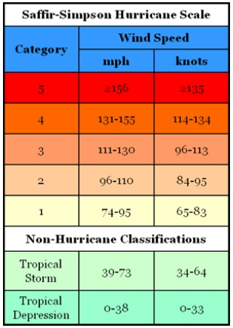
Goliad County and the participating jurisdictions are located far enough from the coast that storm surge in unlikely to have a local impact.
The worst hurricanes and tropical storms in Goliad County and the participating jurisdictions have measured as high as Category 5 on the Saffir-Simpson scale, dropped over 22” in rainfall, injured up to 78 people, and caused property and crop damages in excess of $52.8 million respectively.
Future hurricanes and tropical storms may meet or exceed previous worse-case Category 5 storms in terms of strength, rainfall, flooding, damage dollars, injuries, and deaths.
Location is often referred to in terms of Tier I and II counties, designated by the Texas Department of Insurance (TDI) for windstorm insurance purposes, to represent differing levels of loss exposure to coastal counties and adjacent counties. Tier I ae those counties adjacent to the Gulf of Mexico and Tier II are those counties adjacent to TIER I counties.
Goliad County is a Tier II County. As a Tier II County, all of Goliad County and the Participating jurisdictions are in direct threat of tropical storms and hurricanes, including associated flooding and high winds.
Although tropical storms and hurricane effects begin to diminish as they move inland, the winds alone from Hurricane Harvey reaches as far as 140 miles from the eye of the storm.
The planning team determines that Goliad County is uniformly exposed to tropical storms and hurricanes.
Impacts from a hurricane or tropical storm in Goliad County and the participating jurisdictions may include but are not limited to: loss of power due to downed lines caused by flying debris or fallen trees, flooding, flooding due to damaged or destroyed roofs, damaged or broken windows, damage due to flying debris, wind damage, escaped livestock and pets, injured or killed livestock and pets, crop damage or destruction. In the worst storms, people may be injured or killed.
The participating jurisdictions recognize that vulnerable populations may need additional help preparing for and recovering from a hurricane or tropical storm.
Residents of mobile/manufactured housing are of particular concern. These structures are never considered a safe shelter during a hurricane, and depending on tie-down methods, may also be unsafe during strong tropical storms.
Residents of sub-standard structures are also of particular concern. Structures in sub-standard condition ahead of a tropical storm or hurricane, whether due to structural damages, missing windows or doors, holes in exterior walls or the roof, may be less safe during a hurricane or tropical storm than structures in standard condition. Existing structural weakness may mean increased damages, injuries, or loss of life. US Highway 183 and US Highway 239 are TxDOT designated major hurricane evacuation routes.
- Wildfire
Wildfire is defined as a sweeping and destructive conflagration and can be further categorized as wildland, interface, or intermix fires.
Wildland fires are fueled almost exclusively by natural vegetation wildland/urban interface (WUI) fire include both vegetation and the built-environment. The wildfire disaster cycle begins when homes are built adjacent to wildland areas. When what would have been rural wildfires occur, they advance through all available fuels, which can include homes and structures.
According to the data, fire departments respond to nearly 30 wildfires per year in greater Goliad County. Given prior frequency of wildfire events, a wildfire event in Goliad County is highly likely, meaning an event is probable within the next year.
Goliad ISD is primarily affected by wildfires in the City of Goliad. However, because the ISD own property throughout the County, it may be affected by wildfires outside of the City of Goliad. Given the frequency of wildfire events affecting both of those jurisdictions, a wildfire event affects Goliad ISD is highly likely, meaning an event is probable in the next year.
The Texas A&M Forest Services Characteristic Fire Intensity Scale (FIS) specifically identifies areas where significant fuel hazards and associated dangerous fire behavior potential exist. The FIS is a fire behavior output, which is influenced by three environmental factors- fuels, weather, and topography. According to Texas A7M Forest Service data, Goliad County and the participating jurisdictions are rated between Class I and Class 4.
Class 1- Very Low
Very small, discontinuous flames, usually less than one foot in length; very low rate of spread; no spotting. Fires are typically easy to suppress by firefighters with basic training and non-specialized equipment.
Class 2- Low
Small flames, usually less than two foot long; small amount of very short-range spotting possible. Fire is easy to suppress by trained firefighters with protective equipment and specialized tools.
Class 3- Moderate
Flames up to 8 feet in length; short-range spotting is possible. Trained firefighters will find these fires difficult to suppress without support from aircraft or engines, but dozer and plows are generally effective. Increasing potential for harm or damage to life and property.

Class 4- High
Large flames, up to 30 feet in length; short-range spotting common; medium range spotting possible. Direct attack by trained firefighters, engines, and dozers is generally ineffective, indirect attach may be effective. Significant potential for harm or damage to life and property.
Class 5- Very High
Very large flames up to 150 feet in length; profuse short-range spotting, frequent long-range spotting; strong fire-induced winds. Indirect attack marginally effective at the head of the fire. Great potential for harm or damage to life and property.

The National Wildfire Coordinating Group (NWCG) provides an additional way to measure extent by accounting for fire size. Based on NWCG numbers, the largest fires in Goliad County and the participating jurisdictions have been Class F events. Based on Texas A&M Forest Service Data, the Average fire in Goliad County and the participating jurisdictions is a Class C event.

Class A ¼ acre or less
Class B More than ¼ acre, but less than 10 acres
Class C 10 acres or more, but less than 100 acres
Class D 100 acres or more, but less than 300 acres
Class E 300 acres or more, but less than 1,000 acres
Class F 1,000 acres or more, but less than 5,000 acres
Class G 5,000 acres or more

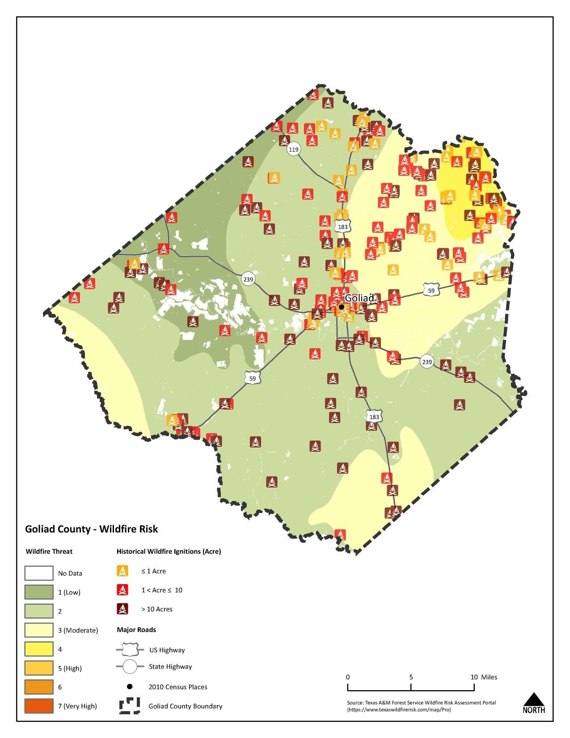
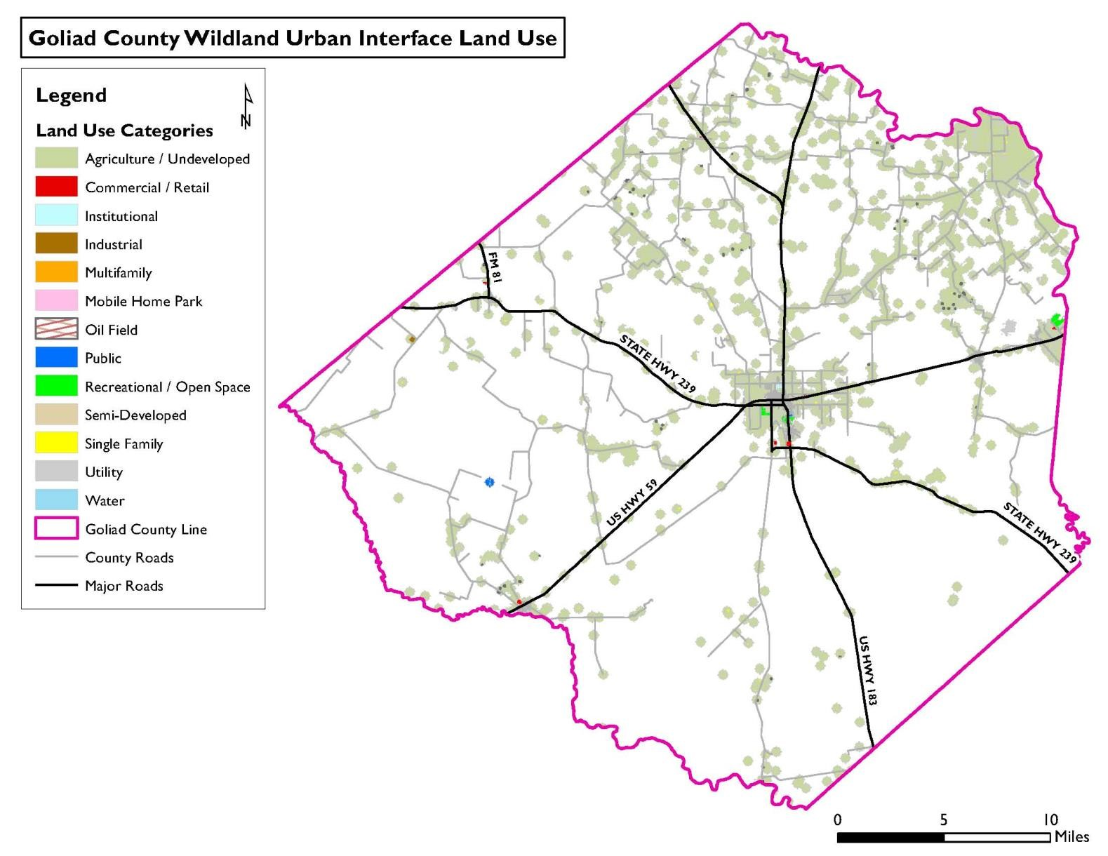

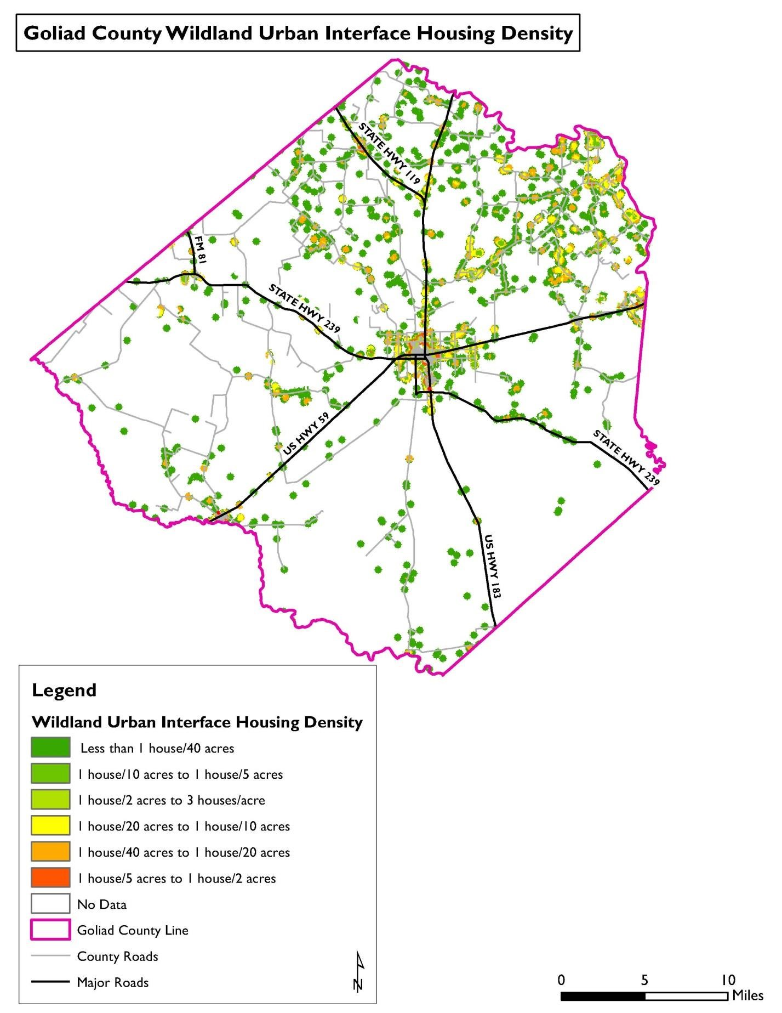

Previous wildfires in Goliad County and the jurisdictions addressing the hazard have ranged between Class 1 and Class 4 on the Characteristic Fire Intensity Scale, with flames up to 30’ in length, and between Class A and Class F on the Nation Wildfire Coordinating Group Size Class of Fire Scale (NWCGSCF). Most fire have been small and were contained quickly. However, the worst reported fire in Goliad County burned 3,000 acres.
Future fire events in Goliad County and the participating jurisdictions may meet or exceed previous worst-case Class F (NWCGSCF) and Class 4 (FIS) wildfires in terms of intensity, acres burned, and inflicted damage.
Due to wildfires ability to inflict damages to both structures and landscapes, wildfire location has been assessed by parcel, rather then by structure. Parcels have been identified by land use type, and have been determined to be either partially or completely vulnerable to wildfire based on TxWRAP’s Wildland Urban Interface boundaries. Certain parcels may contain various land uses. However, parcels have been identified based on the primary land use type.
Impacts from a wildfire in Goliad County and the participating jurisdictions may include but are not limited to: crop damage or destruction, damage or destroyed agricultural, residential, commercial, and industrial buildings, escaped, lost, injured, or killed livestock and pets. In the worst cases, residents may be injured or killed.
The jurisdictions recognize that vulnerable populations may need additional help preparing for and recovering from a wildfire.
Residents of mobile homes, specifically those built before HUD’s Manufactured Housing and Standards requirements were introduced in 1976, are of particular concern. These structures are more prone to fire and have a higher incidence of occupant death than modern manufactured homes.
Residents of sub-standard structures are also of particular concern. Structures in sub-standard condition ahead of a wildfire, whether due to structural damages, missing windows or doors, holes in exterior walls or the roof, may be less safe during a wildfire than structures in standard condition. Exterior damages may make the homes more prone to fire by more readily exposing flammable materials to flame. Missing windows and other exterior gaps may leave residents and structures prone to smoke inhalation and smoke damage.
All of these issues may increase damages and lead to injuries or loss of life.

- Tornado
A tornado is defined as a rapidly rotating vortex or funnel of air extending ground-ward from a cumulonimbus cloud. Most of the time, vortices remain suspended in the atmosphere and are visible as a funnel cloud. However, when the lower tip of a vortex touches the ground, the tornado becomes a force of destruction. Tornado strength is currently measured using the Enhanced Fujita (EF) Scale. Like the previously used Fujita scale, the EF Scale uses damage to estimate tornado wind speeds and assign a number between 0 and 5. A rating of EF0 represents minor to no damage whereas a rating of EF5 represents total destruction of building.
No documented tornados have affected Goliad County in the last five years.
Although neither Goliad ISD nor Goliad WSC has recorded any previous tornados, their locations and tornados’ unpredictable nature means they’re as vulnerable to tornados as every other participant.
Based on the frequency of previous tornados in Goliad County and the participating jurisdictions, a future event that may impact any or all of them is occasional, meaning one is possible in the next five years.
The Enhanced Fujita Scale, or EF Scale, is the scale for rating the strength of tornados via the damage they cause. Six categories from zero to five represent increasing degrees of damage. The scale takes into account how most structures are designed, and is thought to be an accurate representation of the surface wind speeds in the most violent tornados.

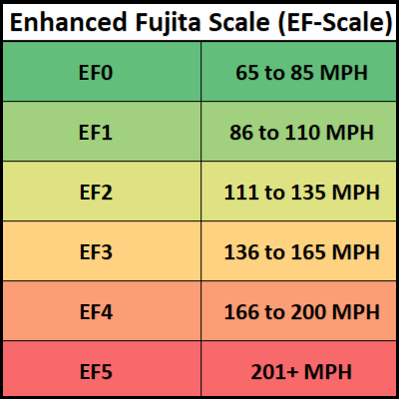
Previous tornados ranged in strength from F0 to F1 on the Fujita Scale. Since the switch to the updated scale, only one EF0 tornado has been recorded. In terms of property damages inflicted, the worst reported tornado in Goliad County and the participating jurisdictions was unrated. Previous tornados have killed up to 116 people and injured up to four people.
Future tornados may be as bad as EF1 and meet or exceed previous ones in terms of total damage dollars inflicted and the number of residents injured or killed. Tornados are not constrained by any distinct geographic boundary. Tornados can occur across all participating jurisdictions, and may freely cross from one jurisdiction into another.
Impacts from a tornado may include but are not limited to damaged or destroyed personal property including vehicles, damaged or destroyed agricultural, residential, commercial, and industrial buildings. Crops may be damaged or destroyed. Pets and livestock may be injured or killed by tornados or flying debris. Pets and livestock may escape de to damaged or destroyed structures and fences.
In the worst cases, tornados may cause injuries and/or be deadly.
Tornados have the potential to impact the entire planning area. All existing and future buildings, critical facilities, critical infrastructure, improved property, and the populations of the participating jurisdictions are considered vulnerable to this hazard.
Goliad County and the participating jurisdictions are home to many vulnerable residents. Increased vulnerability may be de to many factors including but not limited to: age, physical ability, financial means, housing type, and housing condition. Many of these vulnerabilities often overlap.
The participating jurisdictions recognize that vulnerable populations may need additional help preparing for and recovering from a tornado.
Residents of mobile/manufactured home are of particular concern. These structures are ever considered safe during a tornado.
Residents of sub-standard structures are also of particular concern. Structures in sub-standard condition ahead of a tornado, whether due to structural damaged, missing windows or doors, holes in exterior walls or the roof, may be less safe during a tornado than structures in standard condition.
Existing structural weakness, due to housing type or existing damages, may lead to compounded damaged, injuries, or loss of life.

- Drought
Drought is defined as the consequence of natural reduction in the amount of precipitation expected over an extended period of time, usually a season or more in length.
Droughts are one of the most complex natural hazards to identify because it is difficult to determine their precise beginning or end. In addition, droughts can lead to other hazards such as extreme heat or wildfires. Their impact on wildlife and area farming is enormous, often killing crops, grazing land, edible plants and even in severe cases, trees. A secondary hazard to drought is wildfire because dying vegetation serves as a prime ignition course. Therefore, a hear wave combined with a drought is a very dangerous situation.

Meteorological Drought- The degree of dryness or departure of actual precipitation from an expected average or normal amount based on monthly, seasonal, or annual time scales.
Hydrologic Drought- The effects of precipitation shortfalls on stream flows and reservoir, lake, and groundwater levels.
Agricultural Drought- Soil moisture deficiencies relative to water demands of plans life, usually crops.
Socioeconomic Drought- The effect of demands of water exceeding the supply as a result of a weather-related supply shortfall.
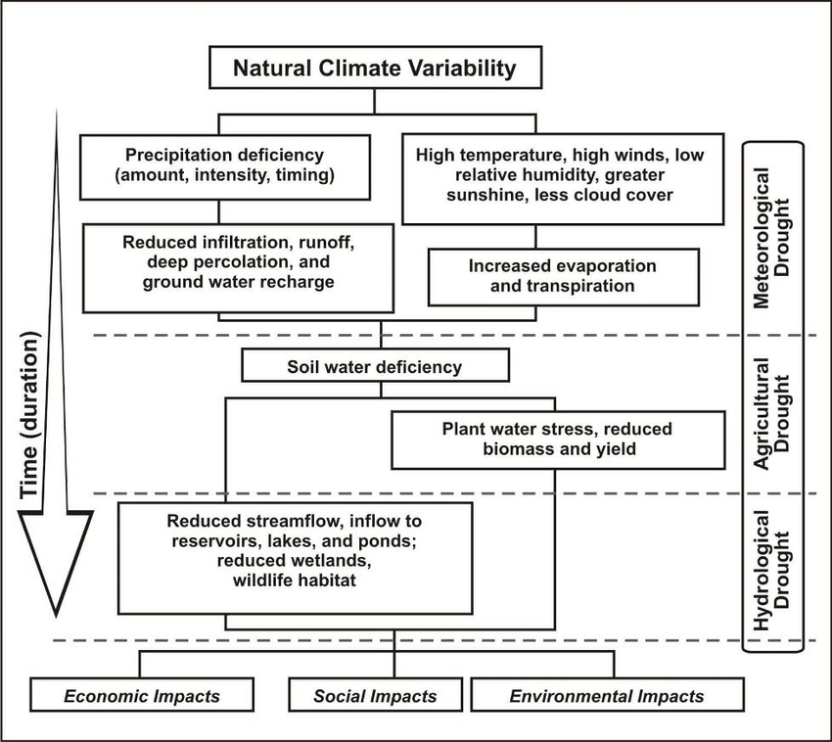

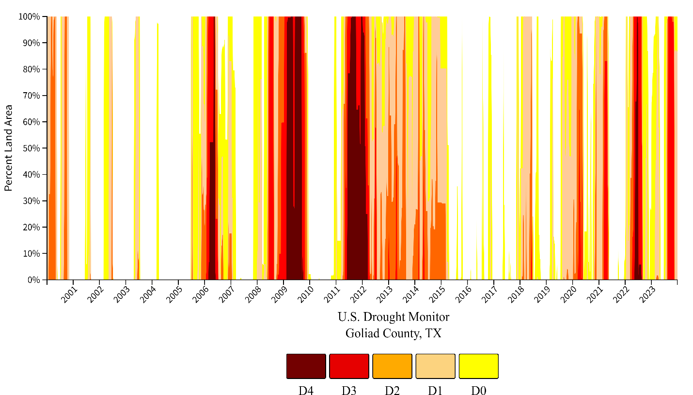

Drought history is recorded at the county level. However, the data is measured by the percentage of the county affected by drought. Although no specific data regarding droughts occurrences in the individual cities is available, it’s possible to use the data in infer when the participating jurisdictions previously experienced drought conditions due to the fact that the conditions impacted 100% of the county. According to the data, Goliad County and the participating jurisdictions have regularly experienced drought conditions since 2001, especially between 2006-2007, 2009-2010, 2011-2012, and 2022-2003.
There are no recorded injuries or deaths due to drought in Goliad County or the participating jurisdictions.
Based on historical drought in Texas and Goliad County, it is likely that a future drought will affect Goliad County and the participating jurisdictions, means an event affecting any or all of the participating jurisdictions is probable in the next three years.
Since 2000, Goliad County has regularly experienced county-wide droughts classified as periods ranging from abnormal dryness to exceptional drought. At multiple times, the entire county, including all participating jurisdictions, has been in exceptional drought, the most severe drought category.
The Palmer Drought Index is used to measure the extent of drought by measuring the duration and intensity of long-term drought-inducing circulation patterns. Long-term drought is cumulative, with the intensity of drought during the circulation patterns. Long-term drought is cumulative, with the intensity of drought during the current month dependent upon the current weather patterns plus the cumulative patterns of previous months. The hydrological impacts of drought (e.g., reservoir, groundwater levels, etc.) take longer to develop.

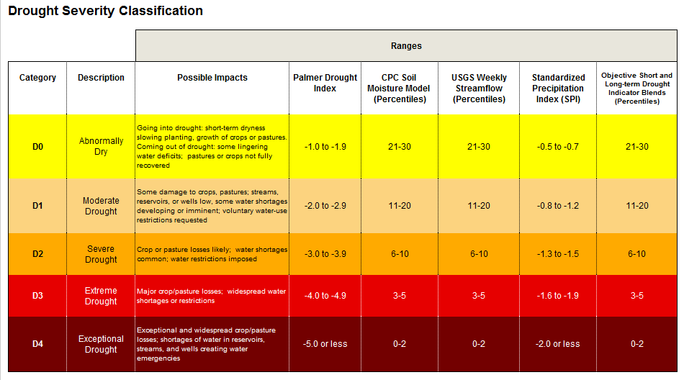

Drought is monitored nationwide by the National Drought Mitigation Center (NDMC). Indicators are used to describe broad scale drought conditions across the U.S. Indicators correspond to the intensity of drought.
Based on the historical occurrences of drought, Goliad County and all participating jurisdictions should anticipate experiencing drought ranging rom abnormally dry to exceptional drought or D0 to D4 based on the Palmer Drought Category. Given varying conditions, droughts may start on the low end of the Palmer Drought Category, but will intensify with duration and an ongoing lack of precipitation.
Future drought events may meet or exceed previous worst-case D4 droughts in terms of intensity, duration, and total damage dollars inflicted.

Drought Index |  | Drought Conditions Classifications
 | Extreme | Severe | Moderate | Normal | Mostly Moist | Very Moist | Extremely Moist
Z Index | -2.75 and below | -2.00 to -  2.74 | -1.25 to -  1.99 | -1.24 to  +.99 | +1.00 to +2.49 | +2.50 to +3.49 | n/a
Meteorological | -4.00 and below | -3.00 to -  3.99 | -2.00 to -  2.99 | -1.99 to  +1.99 | +2.00 to | +3.00 to | +4.00 and above
 |  |  |  |  | +2.00 | +3.00
Hydrological | -4.00 and below | -3.00 to -  3.99 | -2.00 to -  2.99 | -1.99 to  +1.99 | +2.00 to +2.00 | +3.00 to +3.00 | +4.00 and above

Drought has no distinct geographic boundary. Drought can occur across all participating jurisdictions.
Infrastructural impacts may include damage to the foundations of agricultural, residential, commercial, and industrial buildings. Road networks that pass through the County and participating jurisdictions may be damaged to the point of failure as the ground sifts and shrinks. The participating jurisdictions’ water and wastewater systems may fail due to cracks and breaks in underground tanks and pipe networks.
Economic impacts may include: increased prices for food, unemployment for farm workers and ranch hands, and reduced tax revenues because of reduced supplies of agriculture products and livestock that are dependent on rainfall.
Because drought has the potential to impact every jurisdiction equally, all improved property and the entire population is exposed to this hazard. Foundations of all buildings are vulnerable; however, older structures or those built under less stringent foundation code requirements are most vulnerable. Critical infrastructure like water and wastewater lines, roads, and railroads are also vulnerable. Lower income populations who may no have the resources to buy large quantities of bottled water in the vent of a shortage may e more vulnerable than other populations.
Goliad County and the participating jurisdictions are home to many vulnerable residents. Increased vulnerability may be due to many factors including but not limited to: age, physical ability, financial means, housing type, and housing condition. Many of these vulnerabilities often overlap.
The jurisdictions recognize that vulnerable populations may need additional help preparing for and recovering from a drought.
Lower income populations who may not have the resources to buy large quantities of bottled water in the event of a shortage may be more vulnerable than other populations.
Residents of sub-standard structures are also of particular concern. Structures in sub-standard condition ahead of a drought may be more likely to suffer additional damages, including irreparable damage to building foundations as soils shift and shrink. Depending on their financial means, these residents may require additional assistance recovering from drought-caused damages.
In additional to triggering various components of participating jurisdictions’ Drought Contingency plans, drought conditions may affect local critical facilities. Area fire departments may see increased demand for controlling wildland fire due to dry conditions. Drought is likely to require increased output from the local power company, GVEC, in order to keep up with electrical demand. Depending on factors like time of year, temperature, and duration, increased electrical demand may cause blackouts that would impact critical facilities, based on the rarity of previous instances of structural damage is expected to be limited. However, in the worst cases such damage is possible, and may include cracked building foundations, damages to water and wastewater lines that serve facilities, and in certain cases, these physical damages may create economic damages for the broader community.
Water and wastewater systems rely on underground pipe networks to function properly. During extreme droughts, as the ground shifts and shrinks, these pipes become vulnerable to cracks and breaks. Within greater Goliad County, the water and wastewater systems in the City of Goliad and Goliad Water Supply Corporation’s water systems in Berclair and Fannin serve the largest number of residents.
Damage to water and wastewater systems, especially during a drought, maybe severe enough to exceed a jurisdictions ability to immediately fund repairs without outside assistance. Delays to returning these systems to normal functionality will require these jurisdictions to provide emergency alternatives.
Drought conditions may damage road and railroad networks in various ways. Depending on usage and temperature, as soil shifts and shrinks, roadbeds and railroad beds may subside. In the case of railroads, subsidence may lead to failure. A combination of shifting ground, high temperatures, and heavy usage may cause asphalt roads to become rutted.
The Union Pacific railroad in Goliad County primarily runs parallel to US 59 before ending in the unincorporated area of Fannin. A spur connects it to the International Power Coleto Creek power plant. Damages to any rail line, especially to the spur to the power plant, could be catastrophic if they were to cause a derailment or reduce the plant’s fuel supply.
Although surface streets may be most vulnerable to a drought’s effects due to variations in street construction requirements throughout the county and participating jurisdictions, damages to US 183, US 59, and SH 239 would create the greatest impact in Goliad County and the participating jurisdictions because these highways are the County’s primary thoroughfares. US Highway 183 and SH 239 also function as hurricane evacuation routes.
Given agriculture’s role in the County, drought-caused losses will have impacts beyond any individual and may lead to contraction in the wider economy. However, because the data is recorded at the county level, there is no specific information regarding agricultural losses to due to drought for the individual participating jurisdiction.

- Extreme Heat
Extreme heat is defined as summertime temperatures that are substantially hotter and/or more humid than average for a given location at that time of year. Humid conditions, which ass to the discomfort of high temperature, occur when a “dome” of high atmospheric pressure traps hazy, damp air near the ground.
Although heat can damage building and facilities, it presents a more significant threat to the safety and welfare of citizens. The major human risks associated with severe summer heat include: heat cramps, sunburn, dehydration, fatigue, heat exhaustion, and heat stroke. The most vulnerable population to heat casualties are children and the elderly or infirm, who frequently live on low fixed incomes and cannot afford to run air-conditioning on a regular basis. This population is sometimes isolated, with no immediate family or friend to look out for their wellbeing.
Severe summer heat is an invisible killer. Although a heat wave does not happen with the spectacle of other hazards such as tornados and floods, the National Center for Environmental Health reports that extreme heat caused 18,065 deaths in the United States since 2000. Extreme heat kills more people than hurricanes, floods, tornados and lighting combined, according to the National Weather Service.
Extreme heat data is recorded at the county level. However, given the nature of extreme heat and the proximity of the jurisdictions addressing the hazard to each other, they all experienced the same extreme heat events. No damage dollars for any extreme heat event have been recorded in any participating jurisdiction in over 20 years.
Based on historic weather data, extreme heat in Goliad County and the jurisdictions addressing the hazard is highly likely, meaning an event affecting any or all of them is probable in the next year.
The magnitude or intensity of an extreme heat event is measured according to temperature in relation to the percentage of humidity. According to the Nation Oceanic Atmospheric Administration (NOAA), this relationship is referred to as the “Heat Index”. This index measures how hot it feels outside when humidity is combined with high temperatures.

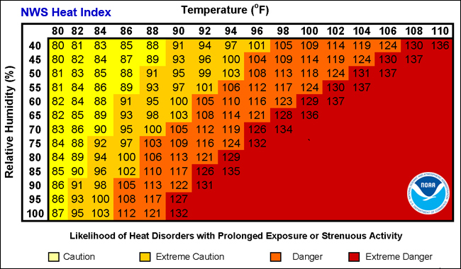

The figure above displays varying degrees of caution depending on the relative humidity combined with the temperatures. For example, when the temperature is below 90 degrees F, caution should be exercised if the humidity level is at or above 40 percent.
The shaded zones on the chart indicate varying symptoms or disorders that could occur depending on the magnitude or intensity of the event. “Caution” is the first level f intensity where fatigue due to hear exposure is possible. “Extreme Caution” indicates that sunstroke, muscle cramps or heat exhaustion are possible, whereas a “Danger” level means that these symptoms are likely. “Extreme Danger” indicates that heat stroke is likely.
Heat Advisory- Extreme heat index making it feel hot, typically between 105 degrees F to 110 degrees F for 3 hours or more during the day and at above 75 degrees F at night.
Excessive Heat Warning- Extreme heat index making it feel very hot, typically about 105 degrees F for 3 hours or more during the day and at or above 80 degrees F at night.
Extreme heat has no distinct geographic boundary. Extreme hear can occur across the entire planning area and uniformly affect the jurisdictions addressing the hazard.
The potential impact of excessive summer hear is normally minor, resulting in few, if any, injuries. No property or crop damage specifically tied to extreme heat events has been recorded in any of the participating jurisdictions in over 20 years. No death related to extreme hear have ever been reported in the participating jurisdictions. However, based on the hazard’s potential, in the worst cases, especially in combined with drought conditions, the hazard may inflict property or crop damages, and it can even be deadly. Any shutdown of facilities due to extreme hear to expected to be temporary.
Goliad County and the jurisdictions addressing the hazard are home to many vulnerable residents. Vulnerable populations may feel greater impacts from extreme heat due to these populations’ limited ability to properly address the hazard due to deficiencies including but not limited to: lack of air conditioning in their homes or vehicles, lack of access to air-conditioned public spaces during the hottest part of the day, insufficient numbers of box or ceiling fans, or lack of access to other means of cooling. The consequences for these populations’ exposure to extreme heat can include but are not limited to” heat cramps, sunburn, dehydration, fatigue, heat exhaustion, heat stroke, or death.
While all of the jurisdictions addressing the hazard are exposed to extreme temperatures, existing buildings, infrastructure, and critical facilities are not considered vulnerable to damages significant enough to interrupt or stop normal operations. Therefore, any estimated property losses associated with the hazard are anticipated to be minimal across the area.

- Severe Winter Storm
A severe winter storm is defined by extreme cold and heavy concentrations of snowfall or ice. Texas is disrupted more severely by severe winter storms than regions that experience severe winter weather more frequently.
The types of severe winter storm which Texans are most familiar with are snowstorms, blizzards, cold waves, and ice storms.
Snowfall with an accumulation of four or more inches in a 12-hour period is considered a heavy snowfall. Snowfall of any amount is rare south of a line from Del Rio to Port Arthur, and it is this rarity of event, coupled with a lack of preparedness for such an event, that creates a severe weather condition.
Blizzards are the most perilous of all winter storms, characterized by low temperatures and strong winds in excess of 35 mph, bearing large amounts of blowing or drifting snow. Blizzards take a terrible toll on livestock and people caught in the open. In Texas, blizzards are most likely to occur in the Panhandle and South Plains Regions.
The passage of a winter cold front with a drastic drop in temperature heralds the arrival of a cold wave, usually referred to as a “blue north-er.”
An ice storm occurs when rain falls out of the warm and moist upper layers of the atmosphere into a cold and dry layer near the ground. The rain freezes on contact with the cold ground and accumulates on exposed surfaces. If a half inch of rain freezes on trees and utility wires, damage can occur, especially if accompanied by high winds, thus half an inch is used as the criteria before an icing event is categorized as an “ice storm”.
Severe winter weather data is recorded at the county level. However, given the nature of severe winter weather and the proximity of all jurisdictions to each other, every jurisdiction experienced the same severe winter weather events. The last case of severe winter weather was recorded in February 2022.
Because it is likely that more winter storms have occurred than have been officially reported, the likelihood of winter storms occurring in Goliad County and the participating jurisdictions is occasional, meaning an event affecting any or all of the participating jurisdictions is possible in the next five years.
The definitions below explain the magnitude of severe winter storms. The wind-chill factor index was developed by the National Weather Service. It neither addresses temperatures above 40 degrees F nor wind speeds below 5 mph.

Frost Advisory- Issued when nighttime minimum temperatures are expected to range from 33 degrees F to 36 degrees F in the growing season.
Freeze Warning- Issued when nighttime minimum temperatures are expected to reach 32 degrees F or lower in the growing season. They are usually issued to highlight the first few freezes of the fall or unusually late freezes in the spring. A Freeze Watch is issued when these conditions may be met 12 to 48 hours in the future.
Snow Advisory- Issued when accumulating snow of 2 to 4 inches is expected. An advisory may still be warranted if lesser accumulations will produce travel difficulties, especially early in the winter season.
Blowing Snow Advisory- Issued when blowing snow is expected to occasionally reduce visibilities to ¼ mile or less with winds generally 25 to 34 mph. The event should last at least 3 hours.
Snow and Blowing Snow Advisory- Issued when winds of 25 to 34 mph are expected to be accompanied by falling snow and blowing snow, occasionally reducing the visibility to ¼ mile or less. The event should last at least 3 hours.
Freezing Rain/Drizzle Advisory- Issued for freezing rain when ice accumulations are expected to cause travel problems, but not exceed 1/4”.
Sleet Advisory- Issued for accumulating sleet of 1/4” to 1”. Because sleet usually occurs with other precipitation types, a winter weather advisory will almost always be used in such cases.
Winter Weather Advisory- Issued for a winter weather event in which there is more than one hazard present, but all precipitation is expected to remain below warning criteria. For example, it would be issued if 2 inches of snow ere expected with a small amount of sleet mixing in at times.
Wind Chill Advisory- Issued when wind chill temperatures are expected to be a significant inconvenience to life with prolonged exposure, and, if caution is not exercised, could lead to hazardous exposure.
Wind Chill Warning- Issued when wind chill temperatures are expected to be hazardous to life within several minutes of exposure.
Ice Storm Warning- Issued when a period of freezing rain is expected to produce ice accumulations of ¼” or greater, or cause significant disruptions to travel or utilities.
Heavy Sleet Warning- Issued when a period of sleet is expected to produce ice accumulations of 1” or greater, or cause significant disruptions to travel or utilities.
Heavy Snow Warning- Issued when snow is expected to accumulate 4 inches or more in 12 hours, or 6 inches or more in 24 hours.
Winter Storm Warning- Issued for a winter weather event in which there is more than one hazard present, and one of the warning criteria listed above is expected to be met. For example, it would be issued if 5 inches of snow were expected in 12 hours, with some sleet mixing in at times. It is commonly issued for heavy snow with strong winds of 25-34 mph that will cause blowing and drifting of the snow. A Winter Storm Watch is issued when these conditions may be met 12 to 48 hours in the future.
Blizzard Warning- Issued for sustained wind or frequent gusts greater than or equal to 35 mph accompanied by falling and/or blowing snow, frequently reducing visibility to less than ¼ mile for three hours or more. A Blizzard Watch is issued when these conditions may be met 12 to 48 hours in the future.

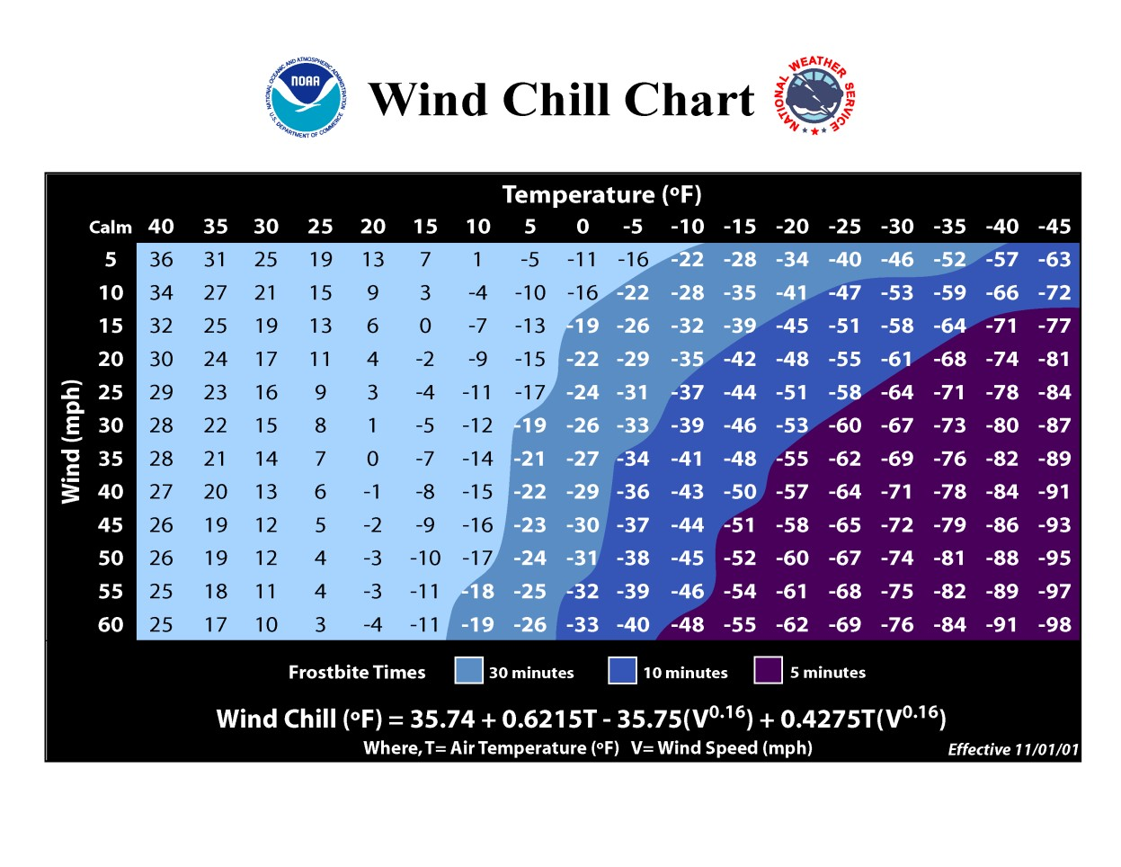

Severe winter weather has no distinct geographic boundary. Severe winter weather can occur across the entire planning area and uniformly affect all participating jurisdictions.
The potential impact of a severe winter storm is normally minor, resulting in few, if any, injuries. Because of the rarity of winter storm events in Goliad County and the participating jurisdictions, drivers, especially those unfamiliar with or unable to drive in icy conditions, may be at the highest risk of crashing their vehicle and sustaining injuries.
Beyond accidents caused by icy conditions, severe winter weather has the potential to cause widespread power outages. Trees and other vegetation that frow along or near power lines and utility lines can become overburdened by ice and snow accumulation. Falling limbs or trees can easily take down power and utility lines. Neglected vegetation is especially at risk of failure due to increased weight loads. Power outages can create a cascading effect depending on residents’ ability to hear their homes without electricity, especially for those young, elderly, and low-income residents as identified earlier in the planning. Although no deaths related to severe winter storms have been reported in the participating jurisdictions, in the worst cases, the hazard has the potential to be deadly.
Severe winter storms will likely cause only minor property damage and minimal disruption to the quality of life in the participating jurisdictions.
Depending on when the even happens, a severe winter storm may damage or destroy crops.
While all of the participating jurisdictions are exposed to extreme temperatures, existing building, infrastructure, and critical facilities are not considered vulnerable to significant damage caused by severe winter storm events. This determination was made based on the expectation that most roofs can support 20 lbs./square foot of snow. Considering the worst ice storms in the participating jurisdictions cause ice accumulations of ½”, it’s unlikely, but not possible, that an ice storm causing structural ice accumulations of less than 4” will cause significant structural damages.

Mitigation Strategy
The planning team reviewed existing regulatory capabilities and opportunities for establishing new capabilities and enhancing existing ones. At this time, all jurisdictions could improve their hazard mitigation capabilities through the following efforts: creating and adopting regularly updated comprehensive plans, budgeting for mitigation actions and support, passing policies and procedures to implement mitigation actions, adopting and implementing stricter mitigation regulations, approving the hiring and training of staff for mitigation activities, and approving mitigation updates and additions to existing plans as new need are recognized.
Goliad County
Administrative, Financial, Regulatory, and Technical Abilities
- Emergency Management
- Economic Development
- Road and Bridge Management
- Tax Collection
- Grant Writing
- General Budgeting
- CIP Funding
- CDBG Funding
- State and Federal Grant Funding
Goliad Independent School District
Administrative, Financial, Regulatory, and Technical Abilities
- Emergency Management
- Comprehensive Planning
- Tax Collection
- Grant Writing
- General Budgeting
- CIP Funding
- State and Federal Grant Funding
Goliad Water Supply Corporation
Administraive, Financial, Regulatory, and Technical Abilities
- Emergency Management
- Drought Contingency Planning
- Tax Collections
- Grant Writing
- General Budgeting
- CIP Funding
- State and Federal Grant Funding

The hazard analysis has shown that Goliad County and the participating jurisdictions are at risk of multiple natural hazards. The following goals and objectives take a broad approach to improving outcomes before, during, and after these anticipated natural hazard events.
The mitigation actions the County and participating jurisdictions have selected are designed to address specific hazard-related issues in support of achieving the desired goals and objectives.
The hazard mitigation plan must strike a balance between identifying long-term goals and objectives and prioritized mitigation actions that may be addressed sooner, depending on funding availability and local priorities. The result is that certain goals and objectives don’t have a corresponding mitigation action. Instead, by taking the long view, the local planning team has created a framework that can be developed as the plan is updated over time.

Goals To Reduce Loss of Life and Injury to Persons
- Improve the delivery and effectiveness of warning messages
- Preserve public and private emergency response capabilities (9-1-1, law enforcement, fire service, emergency medical services, emergency management)
- Utilize available mitigation measurers to prevent or reduce life-threatening impacts of natural hazards
- Reduce obstacles to timely and safe evacuation of flood hazard areas
- Reduce vulnerability to individuals living in mobile homes/manufactured housing
- Reduce life or death threatening impacts on individuals with special physical care requirements
- Reduce secondary impacts to health and safety from cascading effects
Goals to Reduce Disruptions to Essential Public Services and Infrastructure
- Minimize disruption to and enhance rapid restoration of utilities
- Minimize disruption to and enhance rapid restoration of essential transportation infrastructure
- Minimize disruption to governmental, educational, and other institutions providing services to the public

Goals To Reduce Economic Impacts to Individuals, Businesses, And Area Institutions
- Increase home and business owner investment in available mitigation measures for private property
- Increase home and business owner participation in appropriate insurance programs
- Increase public and private sector development and use of operations continuity strategies
- Utilize available mitigation measures to prevent or reduce economic losses from natural hazards
- Reduce vulnerability of existing development by encouraging property owners to participate in buy-out or flood-proofing opportunities
- Reduce vulnerability of future development by utilizing available planning and structural standards
Goals To Reduce Losses to Civic, Cultural, And Environmental Resources
- Protect public investments in community-owned facilities and infrastructure through appropriate structural, non-structural, and financial methods
- Reduce future losses to the non-profit sector through participation in available mitigation opportunities
- Reduce vulnerability of historically or culturally significant structures
- Minimize environmental impacts from cascading effects

Mitigation Action Plan Prioritization
The planning team members have identified at last two mitigation actions per natural hazard. Action items were identified and prioritized in consideration of the following criteria:
- Life safety and property protection improvements
- Cost effectiveness- do the actions future benefits exceed its implementation costs
- Technical feasibility- is the action reasonable given its technical requirements
- Political acceptability
- Administrative capabilities and legal authorities from implementation
- Funding availability
- The action’s environmental impacts
- The action’s social acceptability
- The action’s ability to reduce risk to more than one hazard
- The ease of implementation
- The availability of a local champion
- The action’s relationship to other community objectives
In addition to considering an action’s cost effectiveness as described above, the planning team considered TDEMS cost-Effectiveness, Environmental Soundness and Technical Feasibility requirements as they relate to construction projects. Mitigation actions relating to physical infrastructure will meet the State’s standards as outlined below:
- Any state government construction project, regardless of potential funding source, has to be cost effective, technically feasible and meet all the appropriate federal, state, and local environmental laws and regulations before it is started.
- State government projects funded by Federal Mitigation Grant Programs administered by TDEM have to meet specific criteria related to cost effectiveness, environmental soundness and technical feasibility. These are outlined in the applicable FEMA grant program guidance for that particular funding program.

Each jurisdiction has its own established process for integrating new actions, codes, ordinances, plans, and studies into its existing capabilities. The planning team will ensure that each jurisdiction’s various departments continue to integrate hazard mitigation actions into their day-to-day processes.
Each new mitigation action below outlines the following requirements: the identified responsible department head or delegate will research all relevant information to confirm the action’s feasibility and prioritization, will formulate a plan of action, and will confirm funding sources and identify any fiscal associated with the mitigation action.
As part of each jurisdiction’s commitment to transparency, all relevant information, including but not limited to that described above and in each action’s description, will be presented to the public before the action is formally adopted for implementation. After public notification, the integration process will resemble the one outlined in the chart below.

Jurisdiction | Integration Process
Goliad County | After considering integrating mitigation actions with the activities outlined in Table 51 above, mitigation actions will be presented, considered, and formally adopted by the County Commissioners’ Court and County Judge.  Goliad County will also use the Goliad County Hazard Mitigation Plan as a technical reference and data source for identified and future mitigation actions, as well as future planning processes.
Goliad Independent School District | After considering integrating mitigation actions with the activities outlined in Table 51 above, mitigation actions will be presented, considered, and formally adopted by the school board and Superintendent’s office.  The Goliad Independent School District will also use the Goliad County Hazard Mitigation Plan as a technical reference and data source for identified and future mitigation actions, as well as future planning processes.
Goliad Water Supply Corporation | After considering integrating mitigation actions with the activities outlined in Table 51 above, mitigation actions will be presented, considered, and formally adopted by the board of directors and manager.  The Goliad Water Supply Corporation will also use the Goliad County Hazard Mitigation Plan as a technical reference and data source for identified and future mitigation actions, as well as future planning processes.

Each jurisdiction has selected actions that were identified as high or medium priority and that are in line with TDEM’s recommended mitigation actions. However, many of the mitigation actions below are dependent on outside grant funding for implementation. For all actions likely to require grant funding, potential sources have been identified. However, grant funding is awarded on a competitive basis, so applying for funding doesn’t guarantee that funds will be received. Goliad County and the participating jurisdictions have a successful history for applying for and receiving grant funding to implement physical infrastructure actions. Budget constraints will remain the determining factor for how and when each action is implemented.

Mitigation Action | Educational Outreach
Objective | This action will create a program to educate the public about specific mitigation actions for hazards, including but not limited to  Participating in the National Flood Insurance Program, Wildfire  Fuels Reduction, Improving thermal insulation, Community  Cooling Facilities, Structural Hardening, Reducing Potential Debris, etc…
Hazard | Flood, Hurricane / Tropical Storm, Wildfire, Drought, Tornado,  Extreme Heat, Hailstorm, Severe Winter Storm, Windstorm, Lightning
Priority | High
Estimated Cost | Less than $10,000 per hazard
Potential Funding Source(s) | County, FEMA PDM, FEMA HMGP
Responsible Department(s) | Goliad County Judge & Commissioners' Court  Goliad County Office of Emergency Management
Implementation Schedule | Short Term - 1-5 Years
Target | Existing and future population

Mitigation Action | Purchase Back Up Power Generators
Objective | Installing generators at critical facilities will help ensure physical safety for facility occupants and maintain electronic systems functionality during power outages.
Hazard | Flood, Hurricane / Tropical Storm, Extreme Heat, Hailstorm, Lightning
Priority | Highest
Estimated Cost | More than $100,000 Each for Fixed Generators, Including Associated Engineering Costs.  Less than $100,000 Each for Portable Generators
Potential Funding Source (s) | County, FEMA PDM, FEMA HMGP
Responsible Department | Goliad County Judge & Commissioners' Court  Goliad County Office of Emergency Management
Implementation Schedule | Short Term - 1-5 Years
Target | Existing infrastructure

Mitigation Action | Construct Community Safe Rooms
Objective | The action's goal is to minimize local population vulnerability to hazard events by providing community safe rooms.
Hazard | Flood, Hurricane / Tropical Storm, Wildfire, Tornado
Priority | Medium
Estimated Cost | Less than $10,000 to establish program. Safe Room costs will vary by structure.
Potential Funding Source (s) | County, FEMA PDM, FEMA HMGP
Responsible Department | Goliad County Judge & Commissioners' Court  Goliad County Office of Emergency Management
Implementation Schedule | Short Term - 1-5 Years
Target | Existing and future population and infrastructure

Mitigation Action | Construct Community Safe Rooms
Objective | The action's goal is to minimize local population vulnerability to hazard events by providing community safe rooms.
Hazard | Flood, Hurricane / Tropical Storm, Wildfire, Tornado
Priority | Medium
Estimated Cost | Less than $10,000 to establish program. Safe Room costs will vary by structure.
Potential Funding Source (s) | County, FEMA PDM, FEMA HMGP
Responsible Department | Goliad County Judge & Commissioners' Court  Goliad County Office of Emergency Management
Implementation Schedule | Short Term - 1-5 Years
Target | Existing and future population and infrastructure

Mitigation Action | Purchase Portable Pumps
Objective | This action proposes purchasing portable pumps that can be deployed as needed to reduce the potential impacts of future flood events.
Hazard | Flood
Priority | High
Estimated Cost | $250,000
Potential Funding Source  (s) | County, FEMA FMA, FEMA PDM, FEMA HMGP
Responsible Department | Goliad County Judge & Commissioners' Court  Goliad County Office of Emergency Management
Implementation Schedule | 5 Years
Target | Existing infrastructure

Mitigation Action | Construct Storm Drainage Infrastructure
Objective | This action proposes constructing new storm drainage infrastructure and / or improving existing infrastructure to reduce the potential impacts of future flood events.
Hazard | Flood
Priority | High
Estimated Cost | Greater than $1,000,000
Potential Funding Source  (s) | County, FEMA FMA, FEMA PDM, FEMA HMGP
Responsible Department | Goliad County Judge & Commissioners' Court  Goliad County Office of Emergency Management
Implementation Schedule | 5 Years
Target | Existing infrastructure

Mitigation Action | Install Warning Systems
Objective | An automated flood warning system will help limit local vulnerability to flooding by giving residents up-to-date information about where flooding is occurring.
Hazard | Flood
Priority | High
Estimated Cost | Greater than $1,000,000
Potential Funding Source  (s) | County, FEMA PDM, FEMA HMGP
Responsible Department | Goliad County Judge & Commissioners' Court  Goliad County Office of Emergency Management
Implementation Schedule | Short Term - 1-5 Years
Target | Existing and future population

Mitigation Action | Develop and Implement a New Drought Contingency Plan
Objective | The County will re-evaluate all existing drought control measures to identify strengths and weaknesses in order to develop and enforce a new drought contingency plan.
Hazard | Drought
Priority | Medium
Estimated Cost | $10,000 - $100,000
Potential Funding Source  (s) | County, FEMA PDM, FEMA HMGP
Responsible Department | Goliad County Judge & Commissioners' Court  Goliad County Office of Emergency Management
Implementation Schedule | Short Term - 1-5 Years
Target | Existing and future population and infrastructure

Mitigation Action | Develop and Implement a New Water Conservation Ordinance
Objective | The County will re-evaluate all existing water use control measures to identify strengths and weaknesses in order to develop and enforce a new or updated water conservation plan.
Hazard | Drought

Priority | High
Estimated Cost | $10,000 - $100,000
Potential Funding Source(s) | County, FEMA PDM, FEMA HMGP
Responsible  Department(s) | Goliad County Judge & Commissioners' Court  Goliad County Office of Emergency Management
Implementation Schedule | 1-5 Years
Target | Existing and future population and infrastructure

Mitigation Action | Replace Water Fixtures with Low Flow Units
Objective | This action's goal is to limit water consumption at County-owned and maintained facilities by replacing traditional water fixtures with low flow units.
Hazard | Drought
Priority | High
Estimated Cost | $10,000 - $100,000
Potential Funding Source(s) | County, FEMA PDM, FEMA HMGP
Responsible  Department(s) | Goliad County Judge & Commissioners' Court  Goliad County Office of Emergency Management
Implementation Schedule | 1 - 5 Years
Target | Existing and future infrastructure

Mitigation Action | Set up Cooling Centers in Existing Facilities
Objective | The action's goal is to increase extreme heat resilience by limiting vulnerable populations’ exposure to extreme heat.
Hazard | Extreme Heat
Priority | High
Estimated Cost | Less than $10,000
Potential Funding Source(s) | County, FEMA PDM, FEMA HMGP
Responsible Department(s) | Goliad County Judge & Commissioners' Court  Goliad County Office of Emergency Management
Implementation Schedule | 1 - 5 Years
Target | Existing and future population

Mitigation Action | Set up Warming Centers in Existing Facilities
Objective | The action's goal is to increase severe winter storm resilience by limiting vulnerable populations’ exposure to extreme cold.
Hazard | Severe Winter Storm
Priority | High
Estimated Cost | Less than $10,000
Potential Funding Source(s) | County, FEMA PDM, FEMA HMGP
Responsible Department(s) | Goliad County Judge & Commissioners' Court  Goliad County Office of Emergency Management
Implementation Schedule | 1 - 5 Years
Target | Existing and future population

Mitigation Action | Install Surge Protection to Protect Electronic Assets
Objective | This action proposes installing surge protection at all public facilities to prevent damage to critical electronic devices including but not limited to: computers, servers, audio/visual equipment, laboratory equipment, and appliances.
Hazard | Lightning
Priority | High
Estimated Cost | $10,000 - $100,000
Potential Funding Source (s) | County, FEMA PDM, FEMA HMGP
Responsible Department | Goliad County Judge & Commissioners' Court  Goliad County Office of Emergency Management
Implementation Schedule | Short Term - 1-5 Years
Target | Existing infrastructure

Mitigation Action | Install Grounding Systems to Protect Electronic Assets
Objective | This action proposes installing grounding systems including but not limited to: lightning arresters, grounding rods, and grounding electrodes at all public facilities to prevent damage to critical electronic devices including but not limited to: computers, servers, audio/visual equipment, laboratory equipment, and appliances.
Hazard | Lightning
Priority | High
Estimated Cost | $10,000 - $100,000
Potential Funding Source (s) | County, FEMA PDM, FEMA HMGP
Responsible Department | Goliad County Judge & Commissioners' Court  Goliad County Office of Emergency Management
Implementation Schedule | Short Term - 1-5 Years
Target | Existing infrastructure

Mitigation Action | EOC with Equipped Training Facility with Generator
Objective | Existing EOC is located at the EMS Station. Unable to equip for optimal use. A new Joint EOC/Training Center will provide space to shelter essential first responders during mutual aid & joint agency events as well as provide necessary training for multiple first responders including: Law Enforcement, EMS, Fire Department and Emergency Management.
Hazard | Flood, Hurricane / Tropical Storm, Wildfire, Drought, Tornado,  Extreme Heat, Hailstorm, Severe Winter Storm, Windstorm, Lightning
Priority | High
Estimated Cost | $150,000.00
Potential Funding Source(s) | County, FEMA PDM, FEMA HMGP
Responsible  Department(s) | Goliad County Judge & Commissioners' Court  Goliad County Office of Emergency Management
Implementation Schedule | Short Term - 1-5 Years
Target | Existing and future population

Mitigation Action | Standby Generators
Objective | One county generator to operate courthouse; one at library to run communication hub; and one to run the EMS/EOC
Hazard | Flood, Hurricane / Tropical Storm, Wildfire, Tornado, Extreme Heat, Hailstorm, Severe Winter Storm, Windstorm, Lightning
Priority | High
Estimated Cost | $250,000.00
Potential Funding Source(s) | County, FEMA PDM, FEMA HMGP
Responsible  Department(s) | Goliad County Judge & Commissioners' Court  Goliad County Office of Emergency Management
Implementation Schedule | Short Term - 1-5 Years
Target | Existing and future population

Mitigation Action | Entire County Interlocal Communications
Objective | This action will help eliminate radio dead spots in Goliad County as well allow communications between all county first responder entities.
Hazard | Flood, Hurricane / Tropical Storm, Wildfire, Tornado, Extreme Heat, Hailstorm, Severe Winter Storm, Windstorm, Lightning
Priority | High
Estimated Cost | $10,000,000.00
Potential Funding Source(s) | County, FEMA PDM, FEMA HMGP
Responsible  Department(s) | Goliad County Judge & Commissioners' Court  Goliad County Office of Emergency Management
Implementation Schedule | Short Term - 1-5 Years
Target | Existing and future population

Mitigation Action | Alert Sirens for all of Goliad County
Objective | No existing Alert Sirens are in working condition in Goliad County. Sirens will need to be placed in the following locations:  2 within Goliad City limits, Fannin, Weesatche, Schroeder, Ander-Weser, Berclair, Charco, Sarco,
Hazard | Flood, Hurricane / Tropical Storm, Wildfire, Drought, Tornado,  Extreme Heat, Hailstorm, Severe Winter Storm, Windstorm, Lightning
Priority | High
Estimated Cost | $250,000.00
Potential Funding Source(s) | County, FEMA PDM, FEMA HMGP
Responsible  Department(s) | Goliad County Judge & Commissioners' Court  Goliad County Office of Emergency Management
Implementation Schedule | Short Term - 1-5 Years
Target | Existing and future population

Mitigation Action | Cold Storage
Objective | This action will provide the County with a contingency site to house county vaccines.
Hazard | Flood, Hurricane / Tropical Storm, Wildfire, Drought, Tornado,  Extreme Heat, Hailstorm, Severe Winter Storm, Windstorm, Lightning
Priority | High
Estimated Cost | $2,000.00
Potential Funding Source(s) | County, FEMA PDM, FEMA HMGP
Responsible  Department(s) | Goliad County Judge & Commissioners' Court  Goliad County Office of Emergency Management
Implementation Schedule | Short Term - 1-5 Years
Target | Existing and future population

Mitigation Action | Mobile EOC Vehicle
Objective | This action will provide the County with a contingency EOC mobile vehicle as well as necessary equipment.
Hazard | Flood, Hurricane / Tropical Storm, Wildfire, Drought, Tornado,  Extreme Heat, Hailstorm, Severe Winter Storm, Windstorm, Lightning
Priority | High
Estimated Cost | $200,000.00
Potential Funding Source(s) | County, FEMA PDM, FEMA HMGP
Responsible Department(s) | Goliad County Judge & Commissioners' Court  Goliad County Office of Emergency Management
Implementation Schedule | Short Term - 1-5 Years
Target | Existing and future population

Mitigation Action | Ice Machine
Objective | This action would provide the County with an ice machine at POD for emergency and medical use.
Hazard | Flood, Hurricane / Tropical Storm, Wildfire, Drought, Tornado,  Extreme Heat, Hailstorm, Severe Winter Storm, Windstorm, Lightning
Priority | High
Estimated Cost | $10,000.00
Potential Funding Source(s) | County, FEMA PDM, FEMA HMGP
Responsible Department(s) | Goliad County Judge & Commissioners' Court  Goliad County Office of Emergency Management
Implementation Schedule | Short Term - 1-5 Years
Target | Existing and future population

Mitigation Action | Educational Outreach
Objective | This action will create a program to educate ISD students, faculty, and staff about specific mitigation actions for hazards, including but not limited to  Participating in the National Flood Insurance Program, Wildfire Fuels Reduction, Improving thermal insulation, Community Cooling Facilities, Structural  Hardening, Reducing Potential Debris, etc…
Hazard | Flood, Hurricane / Tropical Storm, Wildfire, Tornado,  Drought, Extreme Heat, Hailstorm, Severe Winter  Storm, Windstorm, Lightning
Priority | High
Estimated Cost | Less than $10,000 per hazard
Potential Funding Source(s) | Goliad ISD, FEMA PDM, FEMA HMGP
Responsible Department(s) | Goliad ISD Superintendent's Office
Implementation Schedule | Short Term - 1-5 Years
Target | Existing and future population

Mitigation Action | Purchase Back Up Power Generators
Objective | Installing generators at critical facilities will help ensure physical safety for facility occupants and maintain electronic systems functionality during power outages.
Hazard | Hurricane / Tropical Storm, Extreme Heat, Hailstorm, Severe Winter Storm, Lightning
Priority | Highest
Estimated Cost | More than $100,000 Each for Fixed Generators, Including Associated Engineering Costs.  Less than $100,000 Each for Portable Generators
Potential Funding Source (s) | Goliad ISD, FEMA PDM, FEMA HMGP
Responsible Department | Goliad ISD Superintendent's Office
Implementation Schedule | Short Term - 1-5 Years
Target | Existing infrastructure

Mitigation Action | Harden Facilities
Objective | This action proposes hardening facilities. Hardening will include but is not limited to building protective walls around exposed gas tanks and cylinders, shielding roof-mounted equipment, and increasing thermal insulation.
Hazard | Tornado, Windstorm
Priority | High
Estimated Cost | Greater than $100,000
Potential Funding Source (s) | Goliad ISD, FEMA PDM, FEMA HMGP
Responsible Department | Goliad ISD Superintendent's Office
Implementation Schedule | Long Term - Greater than 5 Years
Target | Existing infrastructure

Mitigation Action | Educational Outreach
Objective | This action will create a program to educate the public about specific mitigation actions for hazards, including but not limited to  Participating in the National Flood Insurance Program, Wildfire  Fuels Reduction, Improving thermal insulation, Community  Cooling Facilities, Structural Hardening, Reducing Potential Debris, etc…
Hazard | Tornado, Drought, Severe Winter Storm
Priority | High
Estimated Cost | Less than $10,000 per hazard
Potential Funding Source(s) | Goliad WSC, FEMA PDM, FEMA HMGP
Responsible Department(s) | Goliad WSC Board of Directors
Implementation Schedule | Short Term - 1-5 Years
Target | Existing and future population

Mitigation Action | Harden Facilities
Objective | This action proposes hardening facilities. Hardening will include but is not limited to elevating low-lying equipment, upgrading windows and doors to reduce vulnerability to wind and projectiles, and increasing thermal insulation.
Hazard | Flood, Hurricane / Tropical Storm, Severe Winter Storm
Priority | High
Estimated Cost | Greater than $100,000
Potential Funding Source (s) | Goliad WSC, FEMA PDM, FEMA HMGP
Responsible Department | Goliad WSC Board of Directors
Implementation Schedule | Long Term - Greater than 5 Years
Target | Existing infrastructure

Mitigation Action | Construct Flood Control Infrastructure
Objective | This action proposes constructing new flood control infrastructure, including dikes, to reduce the potential impacts of future flood events, especially for low-lying equipment.
Hazard | Flood
Priority | High
Estimated Cost | Greater than $1,000,000
Potential Funding Source (s) | Goliad WSC, FEMA PDM, FEMA HMGP
Responsible  Department | Goliad WSC Board of Directors
Implementation Schedule | 5 Years
Target | Existing infrastructure

Mitigation Action | Construct Storm Drainage Infrastructure
Objective | This action proposes constructing new storm drainage infrastructure and / or improving existing infrastructure to reduce the potential impacts of future flood events.
Hazard | Flood
Priority | High
Estimated Cost | Greater than $1,000,000
Potential Funding Source (s) | Goliad WSC, FEMA PDM, FEMA HMGP
Responsible  Department | Goliad WSC Board of Directors
Implementation Schedule | 5 Years
Target | Existing infrastructure

Mitigation Action | Increase Water Storage Capacity
Objective | This action proposes increasing water storage capacity at Goliad WSC facilities in order to provide additional water supply during times of system failures due to electrical outages.
Hazard | Hurricane / Tropical Storm
Priority | High
Estimated Cost | Greater than $1,000,000
Potential Funding Source (s) | Goliad WSC, FEMA PDM, FEMA HMGP
Responsible  Department | Goliad WSC Board of Directors
Implementation Schedule | 5 Years
Target | Existing infrastructure

Mitigation Action | Develop and Implement a New Drought Contingency Plan
Objective | The WSC will re-evaluate all existing drought control measures to identify strengths and weaknesses in order to develop and enforce a new drought contingency plan.
Hazard | Drought
Priority | Medium
Estimated Cost | $10,000 - $100,000
Potential Funding Source (s) | Goliad WSC, FEMA PDM, FEMA HMGP
Responsible  Department | Goliad WSC Board of Directors
Implementation Schedule | Short Term - 1-5 Years
Target | Existing and future population and infrastructure

Mitigation Action | Develop and Implement a New Severe Winter Weather Contingency Plan
Objective | The WSC will re-evaluate all existing severe winter weather control measures to identify strengths and weaknesses in order to develop and enforce a new severe winter weather contingency plan.
Hazard | Severe Winter Weather
Priority | Medium
Estimated Cost | $10,000 - $100,000
Potential Funding Source (s) | Goliad WSC, FEMA PDM, FEMA HMGP
Responsible  Department | Goliad WSC Board of Directors
Implementation Schedule | Short Term - 1-5 Years
Target | Existing and future population and infrastructure

